**Cryogenic Dangers:**

* **Asphyxiation**
* **Thermal Expansion**
  + **Pressure relief valves usually set at 90% to 105% of MAWP, burst disk at 110%**
* **Skin Damage**
* **Others, I’m sure.**
* 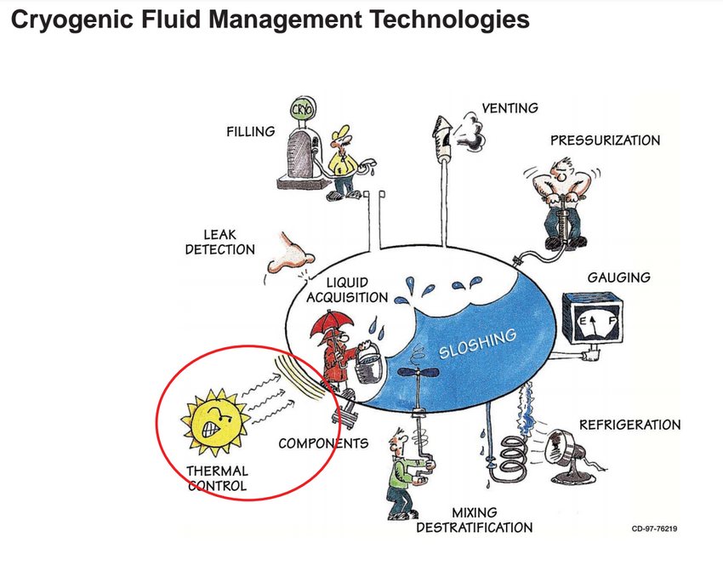

**Considerations:**

* Hazard Analysis Report
  + **Hydro Test**  
    <http://www.dudgeonjacks.com/HYDROSTATIC.html>  
    I got the Model 4A and it makes it really nice to do hydro testing.  People claim grease guns work but I could never get them to work without leaking and making a huge mess.  Just be sure to get rid of all the air and only have liquid when you hydro test in case you burst something.  It's also a good idea to put something between you and the test article, like a brick wall, earth, etc.
* Storage
  + **Storage**:  A normal welding cylinder should be fine in the garage.  Millions of people with a lot less sense than your average aRocket reader store their oxy/acetylene bottles under pressure in the garages for years and you don't hear too much about it.  The main thing is that I always remove the regulator and put the protective cap on it so if it falls over, it will stay intact.

Overpressurization. - NASA

Oxygen cannot be kept liquid if its temperature rises above the critical

temperature of -118.6 °C (-181.4 °F). Consequently, if LOX is trapped in a closed

system and allowed to warm, extreme pressures can overpressurize the system.

For example, LOX trapped between valves can rupture the connecting pipe.

Pressure relief of some kind must be provided where trapping might occur.

Moreover, relief and vent systems must be sized to accommodate the flow so that

excessive backpressures will not occur. Cryogenic liquid storage vessels are

protected from overpressurization by a series of pressure relief devices. These

relief devices are designed to protect the inner vessel and the vacuum-insulated

portion of the tank from failures caused by inner and outer shell damage,

overfilling, and heat load from insulation damage or from a fire.

(1) In specific instances, such as when these vessels are involved in a fire

which impinges upon the ullage area of the tank, container failure could

result. In these instances, water should be directed onto the flame-

impinged portion of the tank to allow the tank to cool. Enough water

should be directed onto this area to keep the tank wet. Water should not be

directed toward the relief devices, as the venting gas may cause the water

to freeze and seal off the relief device.

(2) Frost appearing on the outer wall of an insulated cryogenic vessel is

indicative of vessel insulation loss. Frost appearance is only a clue to the

type of insulation loss. This insulation loss could be caused by a

movement of the insulation in the annular area of the tank, by loss of

vacuum in the annular area, or by inner vessel failure. Assistance from

knowledgeable and responsible pressure-systems personnel should be

obtained.

(a) Personnel should listen and watch for indication of pressure-relief

device actuation. Constant relief actuation is an indication that a

major problem has occurred. Special care should be taken if the

sound of the relief device changes and becomes higher pitched

while operating.

(b) Continued pressure rise while the relief device is actuated indicates

a major system malfunction. If constant relief device actuation is

occurring, immediately evacuate the area and physically rope off

and control the area if this can be performed safely. Venting the

vessel is recommended, if possible. Do not apply water, as this

would only act as a heat source to the much colder oxygen and

aggravate the boiloff.

* Insulation
* Test Stand
  + **Procedures for:**
    - Filling
    - Liquid nitrogen testing?
    - LOx and Ethanol firing
    - Purging Lines
    - Git: <https://github.com/psas/liquid-engine-test-stand/issues/21>
  + **Igniters**  
    See NASA Technical Memorandum 106493 (Hydrogen-Oxygen Torch Ignitor).  Has lots of cross-section drawings of ideas how to mount it to an engine (axial, sideways, angled, etc.)  For your GOX inlet, don't place your restricting orifice right at the point of injection into the igniter.  The GOX jet will come out too fast and erode the opposite wall.  Even having it as little as 0.25 inches upstream was enough to solve my erosion problem.  I used a 0.032 inch (I think) precision orifice but a 0.060 inch orifice into the igniter chamber.  My fuel orifice was 0.008 inches - it has to drop a lot more pressure than the GOX, plus it is a liquid not a gas.
  + **Regulators:**  I too had trouble finding an inexpensive GOX regulator that could go above 200 psi.  I ended up ordering a Victor TPR250-500-992 where the -992 is supposed to be for a CGA992 British oxygen fitting.  The regulator arrived and had "inert gas" stamped on it.  I called Victor and spoke to one of their customer support guys who said the inert and oxygen cleaned regulators have the same parts and go through the same cleaning process.  He said there just isn't much demand for GOX regulators above 200 psi so that's why they don't carry them in the welding line.  I managed to use mine up to 350 psi but that's just my experience with this one regulator.   On valves and regulators, just make sure all seals are oxygen compatible (Viton, PTFE, etc.)
  + **Firing**:  I usually wait a few minutes after running.  If you have a temperature sensor on your motor, you can watch it until it cools down.
* Cleaning
  + **Cleaning**:  This has been discussed before on aRocket (I asked similar questions).  Disassemble everything, clean everything in a solvent (some use IPA, I use acetone), use cotton swabs for cleaning the threads, etc.,  then I end up washing in Dawn soap and distilled water. Dry it all out and reassemble with GOX compatible grease (Krytox).  I only clean parts when I suspect contamination or if I've run water through the lines (water drops turn to steel at LOX temperatures).
  + **Lubricants, Gaskets & Seals** – See NASA Propulsion Test Handbook on Drive
    - **OmniSeals**?

**1) Plumbing Parts in contact with GOX:**

a. Regulator: what type of regulators are people using for GOX? From looking on McMaster I can see that most GOX regulators run to about 200 psi.

Any pressures higher than this get quite expensive. Are people running

engines GOX with a higher pressure? If so what types of regulators are being used? Any issues running engines at such low pressures besides the obviously larger size?

You can use any regulator with materials and seals that are oxygen

compatible. Figuring out what black o-rings are made out of, or what's

in a sealed part of a regulator, is about the most difficult part.

Looking for stuff that is used in high pressure air for SCBA use is a

good start. 6000psi air has many of the same hazards as high pressure

GOX. Aqua Environment makes reasonably priced gas hardware, which you

can buy through Aerocon Systems.

b. I can purchase a solenoid valve that is cleaned for oxygen use but most other parts: eg. connectors, tubes, filters, check-valves, etc… are not. What approaches do people recommend for cleaning parts (on a limited

budget)? Also, how often should parts be cleaned (eg. after every test, only when the plumbing is opened up to the atmosphere or could have become contaminated, etc…)?

You can send stuff off to be lox cleaned, but that's less common in

the hobby world. There they use a series of different solvents to

clean out everything.

The abbreviated process for amateurs is as such:

1. Clean the part with soap and water to remove any dirt or grease or

other visible contaminant. Use whatever is handy to mechanically

clean, as long as it doesn't leave a residue like fibers.

2. Clean the part with pure isopropyl alcohol (IPA) until clean. For

small parts like bits of a regulator or o-rings, easiest is an

ultrasonic cleaner. For tubes, ramrod through kimwipes soaked in IPA

until they come out clean.

3. Remove the IPA by letting air dry in a clean area, baking at

whatever temperature the part will withstand, or putting under vacuum.

Hook up a good filter to a good air supply (or use nitrogen bottles

through a clean regulator) to blow parts dry and blow out tubing.

4. Store parts until needed with clean caps, or wrap in aluminum foil.

Household heavy duty aluminum foil is effectively lox clean.

If you flare the tube after cleaning it, re-clean the flared ends

before use. Clean AN and Swagelok nuts and fittings, even though

they're not supposed to touch the working fluid, because leaks will

touch them. You don't want lox spiraling out threads full of oil.

When reassembling, use oxygen compatible lubricants. The manufacturer

of the regulator will often have recommendations for that, but

Dupont's Krytox line is a common substitute for just about anything.

It's not a great lubricant, but there aren't many gox/lox compatible

ones out there.

Professional lox cleaning companies use IPA as the last step, so it's

what I stick with. Earlier in the process they also use other acids or

bases to degrease stuff they can't get at.

Re-clean when you think the part is contaminated. Re-cap stuff when

you disassemble so it stays clean, exposure to air is not

contamination. Using ethanol, you're pretty safe against unexpectedly

durable residues.

* Transportation
  + **Transportation**:  It really shouldn't leak but I wouldn't sweat a short trip in the car.  A pickup (strapped down!) would be better though.  Those DOT rated cylinders are really tough.
  + **Section 801 e** of NASA Doc.

Transport Requirements for Liquid Oxygen.

General requirements for the transport of LOX are given in 49 CFR 172.101

(1986), Hazardous Materials Table, and 49 CFR 173 (1986), Shippers-General

Requirements for Shipments and Packaging. The proper shipping name for LOX

is Oxygen, refrigerated liquid (cryogenic liquid).

(1) Packaging must be labeled NON-FLAMMABLE GAS, OXIDIZER.

(2) Packaging requirements are given in 49 CFR 173.316 (1986), Cryogenic

Liquids in Cylinders, 49 CFR 173.318 (1986), Cryogenic Liquids in Cargo

Tanks, and 49 CFR 173.320 (1986), Cryogenic Liquids, Exceptions.

Specifications for the qualification, maintenance, and use of cargo tank

motor vehicles are covered in 49 CFR 173.33 (1986), for the design of

insulated cargo tanks in 49 CFR 178.338 (1986), and for the loading and

unloading of cylinders in 49 CFR 177.840 (1986), Class 2 (gases)

Materials.

(3) Liquid oxygen is not permitted aboard passenger aircraft, passenger

railcars, or cargo aircraft. It may be stowed only above deck on cargo

ships.

**Section 802 b:** Noncommercial Equipment and/or Special Operations.

Special equipment or operations used for the transport of oxygen must meet federal and state labor requirements (29 CFR 1986) as well as additional requirements of the cognizant NASA authorities.

**Section 802 c:** Guidelines for the Design of Noncommercial Transport Equipment.

(1) General guidelines. Where applicable, standard oxygen design practice

should be used (Chapters 3 and 4).

(a) The tankage design will be in accordance with accepted design

practice (ASME 1995a, b).

(b) Redundant relief protection must be provided to the tank and

piping systems.

(c) The design of the undercarriage shall isolate the tank and piping

systems from potential collision damage.

(d) Controls should prevent oxygen venting while the vehicle is in

motion.

(e) The trailer should use a fail-safe emergency brake system.

(2) Requirements for highway service. The design of noncommercial vehicles

must comply with federal and state transportation guidelines (see 801

above) for operation on public thoroughfares. In addition to the general

guidelines above, the design must meet highway standards for cargo tank

design (49 CFR 178.338 1986 for cryogenic transport and 49 CFR

178.337 1986 for gas carriers).

**802 D: General Operating Procedures.**

The following guidelines apply to all oxygen transport operations.

(1) General.

(a) Operational areas should remain clear of nonessential personnel.

Appropriate personnel protective equipment should be used.

Facilities should maintain necessary deluge systems.

(b) Transport systems should be adequately grounded.

(c) The operational area should be kept free of combustible materials.

Spark-producing and electrical equipment that is within the

operational area and is not hazard-proof should be turned off and

locked out. All tools used shall comply with established safety

requirements.

8-5

(d) All tank inlets and outlets, except safety relief devices, should be

marked to designate whether they are covered by vapor or liquid

when the tank is filled.

(e) The temperature of LOX is so low that liquid air will form on

uninsulated transfer equipment and vaporizers. Drip pans should

be installed under all such equipment. The concern is that LOX

will come off separately from LN2 as the liquid air returns to a gas.

Oxygen will vigorously support combustion of any materials such

as paint, oils, or lubricants that make up the cargo tank or may be

found on the ground.

(f) Trailers shall be equipped with a dry-chemical fire extinguisher.

The rating shall not be less than 10 BC.

(g) In the event of a oxygen leak the transfer must be stopped and the

leak repaired. In the event of a fire the oxygen sources should be

isolated as quickly as possible.

(h) Operational procedural checklists should be used.

Note: LOX forms shock-sensitive explosive compounds with

carbonaceous materials. Transfer operations should not be conducted

over asphalt surfaces or porous surfaces such as sand that may hide

the presence of oils and greases.

* PPE
  + **Distance**:  I'm a bit conservative here but assume the worst case of the motor detonating and ask yourself what needs to be in the way.  I use 1 inch Lexgard blast shield around the motor and then I have the whole assembly in a 4 foot earth pit with a berm on the sides.  But that's for the large motor testing (100-250 lbf).  For igniter testing (1-2 lbf), I use the blast shield and get behind the brick wall of the side of my garage.
  + **Clothing**:  cotton only - synthetics tend to fuse to your skin when melted.  Cotton just chars away.  And no goop in the hair either.  I use regular safety glasses and also a face shield when working with LOX.
  + Responses from Ben Brockert:

**Clothing/Eye Protection:**

a. What sort of clothing protection is recommended?

Always safety glasses. When working with LOX, also a face shield,

which is always worn with safety glasses. A long sleeve shirt and long

pants is a good idea, natural fibers or specifically fire-resistant

only. McMaster has a variety of flame-resistant coveralls and

* jumpsuits.
* Again, I'm really glad you're worried about this, but over time you
* will likely get less worried. Somewhat with cause, and somewhat just
* because you've always been lucky. I've seen "professionals" do things
* like walk through puddles of LOX or cool themselves off by sticking
* the LOX tank exhaust into their clothes. Don't be that guy.
* But they almost always get away with it, until someone blows off their
* foot. I'll admit that I've touched LOX on more that one occasion.
* With high pressure GOX, the pressure is probably more a hazard than

the ox. Watch out for damaged hoses.

Nasa and others have GOX and LOX safety publications, googling around

for them is a good idea. That said, one talks about the procedure for

doing lox transfers on asphalt, which is simply something I never

would design into my process. So don't take them as always

authoritative.

* Fail modes – relief valves/venting
  + **Burst Discs**  
    <http://www.oseco.com/products/holders-and-accessories/threaded/>  
    You can use a standard disc and holder (recommended) or have a custom disc made and build your own holder (like I did but was a lot of work).  Pressure relief valves work too but they can stick, especially if exposed to cryo temps.  Burst discs are super simple and guaranteed to work.  Be sure to point the burst disc vent away from any nearby people when doing test stand checkout.  They can fatigue and fail early (surprises the heck out of you...)
  + Identify LFE testing computer system control loop characteristics - <https://github.com/psas/liquid-engine-test-stand/issues/6>
* Testing – Permits, City Ordinances, etc.
  + See manual (template) for launch and apply it to test stand.
  + Ensure compliance with
    - ASME,
    - Cryo handling,
    - Boiler Code, etc.

**aRocket archives**  
In addition to the Freelists archive, check out:  
<http://blastzone.org/aRocket/arocketlogin.asp>  
These go back to 1995 and have a lot from the early days of Armadillo, Masten, XCOR, etc.